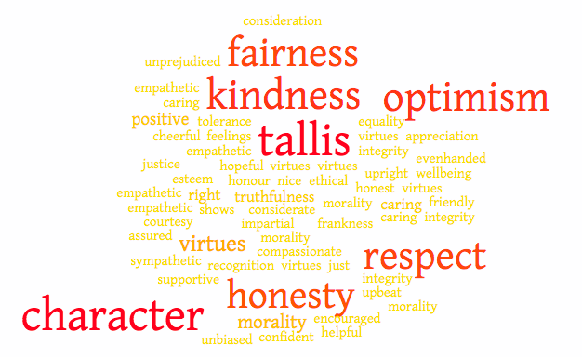
WAYS ADULTS CAN HELP STUDENTS TO DEVELOP THEIR INTERNAL COMPASS FOR EACH TRAIT (adapted from Roots of Action)

KINDNESS • Create emotional attachments with students, ensuring they are seen, felt, and understood. • Provide opportunities for students to know people with different worldviews and life experiences. • Introduce young children to service, helping them understand their roles in helping others. • Talk with students about the meaning that results when they put kindness and compassion into action.

HONESTY • Listen to students’ feelings and concerns without judgment. • Help students identify their own strengths of character by praising them for their courage, honesty, and fairness — not just for grades and external accomplishments. • Model internal strengths, like integrity, humility, and open-mindedness. • Discuss the traits of heroes and heroines in movies, TV, and books —and the consequences of their actions.

OPTIMISM • Push students gently to the edges of their comfort zones and help them to see the benefits. • Help students avoid negative first impulses by thinking through alternative reactions to difficult situations. • Give youth encouragement and support as they learn to take risks, overcome challenges, and grow from failure. • Praise them for their initiative and persistence. • Let students know you believe in them and their abilities.
RESPECT • Treat students with respect and dignity. • Engage them in conversations about values, beliefs, attitudes, and moral dilemmas. • Bring meaning to students’ lives by helping them reflect about who they are and what they care about. • Foster young people’s abilities to connect self-respect to action in the world. • Listen to what students have to say

FAIRNESS • Allow students to have a say. • Engage them in discussions about justice and equality. • Treat all students equally. • Foster students’ understanding that fairness does not always mean that everyone has or is the same. • Use restorative justice practices. • Praise students when they attempt to solve conflicts by considering all parties

WHAT IS CHARACTER EDUCATION?

WHAT IT IS… | WHAT IT IS NOT…
- All educational activities that help young people to develop a moral compass  - The culture and ethos of a school or classroom  - Ethical and ‘right’ action, common morality  - Something that happens in our classrooms whether we acknowledge it or not  - The Tallis Way, or what we want it to be | - Moral indoctrination  - Promotion of moral ideas of a particular belief system  - Based on the values of an individual or small group  - Mindless conditioning  - Exclusively religious  - Individualistic or conservative

Tallis Character is about helping young people to become thinking and caring adults who can flourish throughout their lives. A concerted effort to help the members of our school community to live the values outlined in by the character traits will not only strengthen the Tallis Community by placing a focus on how we treat others, but will also contribute to the overall success of the students.

HOW TO PROMOTE THE CHARACTER TRAITS

- Use the vocabulary of character
- Think of the way you give and receive praise
- Plan how to develop your classroom culture
- Share your ‘at best’ stories
- Use Affirmation or Correction feedback
- Model the traits
- Make use of ‘teachable moments’
Handy guide to…

Character Education and Community
TALLIS CHARACTER
THE VOCABULARY OF CHARACTER
AFFIRMATION AND CORRECTION

The way that you talk with students, praise and give feedback can all have an impact on how students understand and get to know the character traits. There are times when the use of the traits should be recognized (Affirmation) and time when a student’s behaviour will need to addressed (Correction).

The following table gives several basic examples of how staff can comment on behaviour so that the Tallis Character traits are highlighted. It is obvious that not all situations will give rise to occasions appropriate to this purpose. However, the same formula can be used in commenting on the Tallis Habits.

 | AFFIRMATION | CORRECTION
Behaviour | Hamid, offering to work with that student was a really kind thing to do. Thank you.  I appreciate your honesty in letting me know that you forgot about your homework. When will you have it done by? | Hamid, it is not kind to ignore people. Next time I would like to see you include others.  Giving excuses about not completing your homework is not very honest. It would be better to tell the truth so that we can work on whatever the problem is.
Relationships | The way you responded to Daisy’s idea was very respectful Tasmin | Tasmin, the way you responded to Daisy’s idea was not very respectful. Respect is one of our core values. How could you respond to her in a way that is more respectful?
Work | I understand how disappointing it is when your results are lower that you wanted. But your commitment to studying harder shows great optimism. | I understand how disappointing it is when your results are lower that you wanted. But giving up shows a lack of optimism and means that you won’t …

The core feature of this model is in the use of the specific words of the traits to identify appropriate behaviour. Becoming familiar and comfortable with using the vocabulary of the Character traits is an important part of modeling, teaching and embedding Tallis Character. Our interactions in and out of the classroom should be based on these moral virtues. There are many others that we can talk to students about, of course. But the five Tallis Character traits are the ones that we are focusing on as a community.

At Tallis we believe that who we are and how we treat each other is an essential part of preparing for a happy and successful future, as well as achieving our best and flourishing now.

As a community we agreed on five core character traits which make us ‘Tallis’. Developing these traits will mean that we will be;
Kind
Honest
Respectful
Fair
Optimistic

What is Kindness?
Being caring and compassionate. Simply put, it means ‘be nice to people’.
Other words for Kindness are; caring sympathetic, empathetic, friendly, supportive, considerate, helpful

What is Honesty?
Truthfulness. Simply put, it means to do what is right.
Other words for Honesty are; ethical, morally upright, truthfulness, frankness, integrity

What is Respect?
Thinking and acting in a way that shows others that you care about their feelings and their wellbeing. Simply put, it means ‘everyone counts’.
Other words for Respect are; esteem, tolerance, appreciation, consideration, courtesy, honour, recognition

What is Fairness?
Doing something in an honest and evenhanded way. Simply put, it means being just.
Other words for Fairness are; impartial, unbiased, unprejudiced, equality, justice, right

What is Optimism?
Expecting everything will turn our well. Optimism means believing that positive results are likely. Simply put, it means ‘be positive’.
Other words for Optimism are; cheerful, confident, hopeful, assured, positive, upbeat, encouraged

