Target Setting and Data Changes

Monday 5th September INSET Day

New year 7s – new KS2 attainment

Scaled Scores in Reading, Grammar, Punctuation and Spelling, and Mathematics.

Minimum Score: 80

Maximum Score: 120

National average scaled scores 2016

Reading: 103

Grammar, Punctuation and Spelling: 104

Mathematics: 103

A scaled score of 100 corresponds to a student who has met the pre-determined “Expected Standard.” This does not correspond to an old level 4b.

A scaled score of 110 or above is a “high score.” This boundary was arithmetically determined after the tests were taken, and represents approximately the top fifth of students.

Our new year 7s are approximately in line with the national average in each subject, except reading, where a greater proportion of them met the “Expected Standard” than was the case nationally.

New points system – attainment at KS4

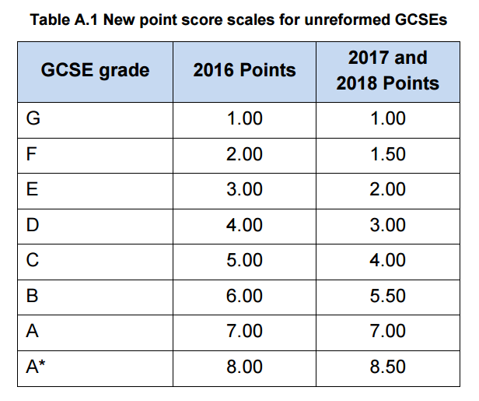

Target Setting at KS4 – new model

Each student is given a National average grade and an FFT20 estimate

Teachers are asked to set a target which is on or above the National average grade, informed by the FFT20 estimate

Student progress is tracked as the difference between predicted grade and National average grade

FFT20 estimates should be used to guide teachers in setting aspirational and appropriate targets for students. They will no longer be used as a measure of student progress.

Linearisation at KS5

Teachers of linear A-Level subjects will submit end of course targets and predictions only in year 12 and 13. AS targets and predictions will no longer be requested in those subjects.

Progress will be tracked as the difference between predicted grade and A2 Alps 3 grade in year 12 and 13.

AS Alps grade will be provided for info only.

Summary of Progress Measures

|  |  |  |  |
| --- | --- | --- | --- |
|  | KS3 (+Y9) | KS4 | KS5 Linear A-Levels |
| Difference between… | End of year Threshold | GCSE/BTEC Predicted Grade | A2 Predicted Grade |
| and… | Baseline Threshold (National average KS4 outcomes) | National Average Grade | A2 Alps 3 Grade |
| Expressed as… | Below  Good  Outstanding | Fractions of Grades | Fractions of Grades |

Assessment Calendar – Autumn 2016/17



Notes