Using a Pillar Drill Safely
Fact Sheet

Space
Make sure you do not leave too much space between you and the machine while you are using it. Passers-by can accidentally push you toward the machine and into moving parts if there is a lack of space, causing injury. Ensure that you are working on a dry floor to avoid slips which may also result in contact with moving parts. Loose items should also be moved away from the machine and your work area to prevent them from going into the machine while you are working. Other people should not be working to close to you, queuing behind you or walking past you.

Clothing
Always wear protective goggles/glasses that provide all-around protection for your eyes when drilling materials. Your goggles should fit snugly, securely and be worn at all times while drilling to prevent particles from being thrown violently into your eyes. Tuck in or take off ties and jewellery, tie long hair back, and roll up or remove any clothing with loose or long sleeves.

Chuck Guard
When using a pillar drill, always use the guard as it is one of the most important parts of the machine in terms of safety. The guard can be adjusted and is used to keep long hair or loose clothing from becoming entangled in moving parts of the drill. Should this happen, turning off the machine may not be enough to prevent your clothing or hair from being wound in, risking your scalp coming into contact with the chuck or drill. Therefore, the guard should be properly adjusted and used whenever you use the machine.

Chuck Key
The chuck key can be the most dangerous part of the machine. Leaving the key is one of the most dangerous things you can do because once the chuck is switched on, the chuck key can come flying out, causing injury to you or someone in the immediate vicinity. It is important that you always check that the chuck key is returned to its storage position before you turn on the machine.

Holding Devices
When drilling holes into any material, use a holding device, such as a clamp, to securely and safely hold the material in place. Alternately, you can also use a machine vice, which is a mechanical screw apparatus used for holding or clamping materials. Never hold materials with your hands while drilling as sharp edges on drills and pieces that you work with can cause cuts. If your skin comes into contact with cutting fluids, oil and grease, it may irritate your skin. In addition, you can also burn yourself by holding materials with your hand as drilling can cause pieces to become hot.
Drill Bit
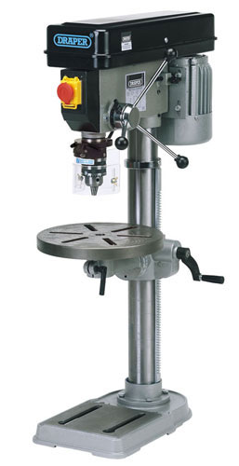
Always ensure that the drill bit is securely held in the chuck before drilling. Never touch the drill bit directly after drilling with it as it can get very hot.

Basic Parts:
On/Off Buttons
Lowering Handle
Chuck
Chuck Guard
Table
Table Height Adjuster
Pillar

