To get level | You might have:
3 | - Drawn some pictures to show:  - Lots of sperm swimming to the egg.  - Sperm and egg meeting.  - Foetus growing in the womb.  - Labelled some parts of the diagrams.  - Written a short sentence to describe what happens for some of the events.
4 | For each heading:  - Correctly used the key words in the cartoon.  - Identified and named the major parts of the reproductive system correctly.  - Simply described fertilisation and implantation using the key words.
5 | For each heading:  - Simply described each stage using the key words accurately.  - Identified the place in the reproductive system each event takes place.  - Described what happens to cells during fertilisation.  Also:  - Simply described and drawn the sperm and egg cell.  - Labelled the main parts of each cell.
7B Task Sheet (L3-5)
The race to make a baby
Key words:
birth, egg, embryo, fertilisation, foetus, implantation, ovary, penis, placenta, sperm, vagina, womb

Level ladder:
What is your target level? Use the level ladder to help you reach it:
Y7 Level-Assessed Tasks © Badger Publishing Ltd
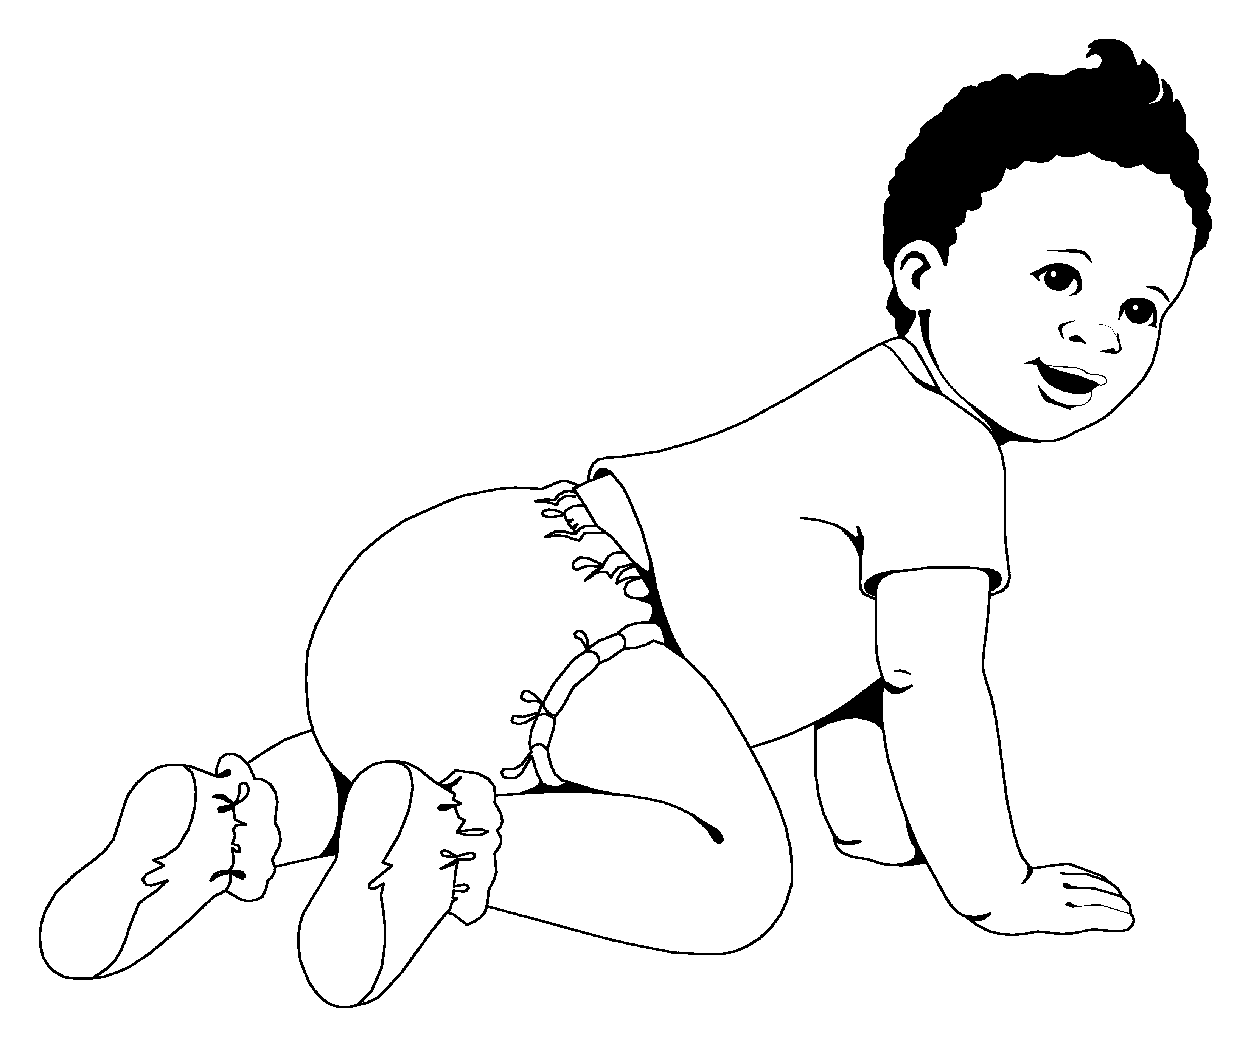
Describe and explain what happens when a sperm and egg meet to make a baby.
You can do this by writing a short story or a cartoon strip.
These are the five headings you must include:
- The sperm race begins.
- Meeting the egg.
- The journey to the womb.
- Growing in the womb.
- Time to be born.
For each heading, make sure you clearly show where it takes place.
Describe the main events that happen.
Use as many scientific words as you can to describe what happens.

