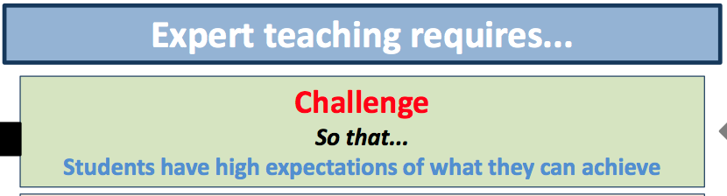



Challenge – a planning and reflection tool

* Are all students expected to develop their knowledge and skills during the lesson?
* Are learning objectives challenging for all?
* Is the bar of expectation high for all students?
* Is appropriate support and scaffolding in place to enable all students to achieve this level of expectation?
* Is formal, subject-specific, academic language modelled by teachers and encouraged from students?
* Are examples of excellence shared, discussed and deconstructed with the class?
* Is subject content relevant and challenging?