21st September 2012

Dear Parent/Carer

I am writing to all parents and carers of Year 12 students to determine the provision required for students with additional learning needs. I would be grateful if you could please complete the form below and return it to me via your son/daughter’s tutor. The information you provide will be shared with relevant staff in order to further support teaching and learning. Please be aware that any students who received additional support in GTCSE exams, eg additional time or a separate room, will need to be reassessed, for this entitlement at sixth form, in advance of the exam period. Should you not return this form, we cannot guarantee your child will receive additional support.

If you have any questions, please do not hesitate to contact me either at the school, or via email erobertson@thomastallis.org.uk

Yours sincerely
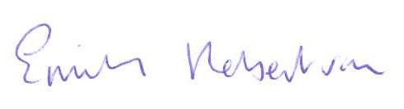

Emily Robertson (SENCO)

Name of student: Tutor Group:

Name of school attended prior to year 12:

- Did your son/daughter have any learning needs which required additional support at Key Stage 4? Yes / No
If yes, please specify these needs, eg dyslexia, autism, dyspraxia

- Did your son/daughter receive any of the following measures of support at Key Stage 4?

- Exam dispensation (eg additional time separate room, scribe, reader, other (please specify)

- Support from a Learning Support Assistant in lessons?
- Use of a laptop in lessons, or other learning aids (please specify)

- Would you like your son/daughter to be assessed for additional support in Key stage 5 exams? Yes / No

Parent / Carer Signature: Date:

