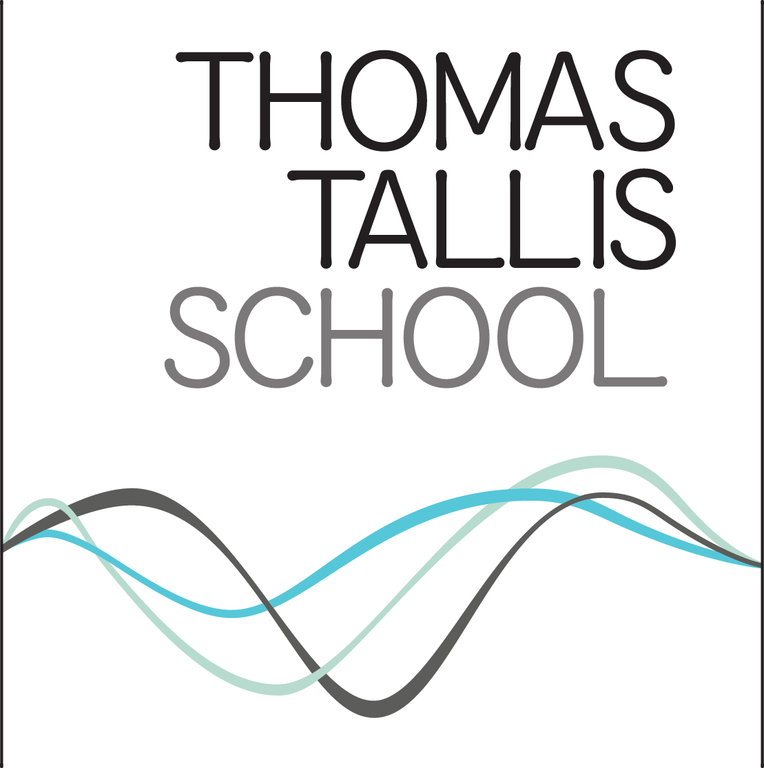
Tallis Curriculum CPD Tuesday 24 April 2018

 | What have I tried so far? | What will I try next?
Making It Stick
More Able Learners
Vocabulary Development

