Thomas Tallis School community garden 2020 and a plea for bees

In December 2019, the community garden was little more than a few empty, half rotten raised beds filled with weeds. There was very little biodiversity on the site bar a few stray pollinators looking for a quick meal and slugs. In place of an abundance of wildlife, there was an abundance of litter and debris. Rotten pallets, buckets, pots and Dorito packets called the garden ‘home’.

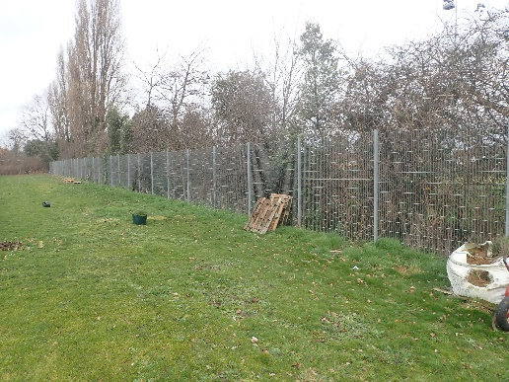
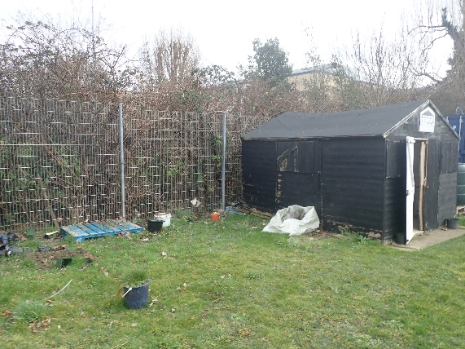
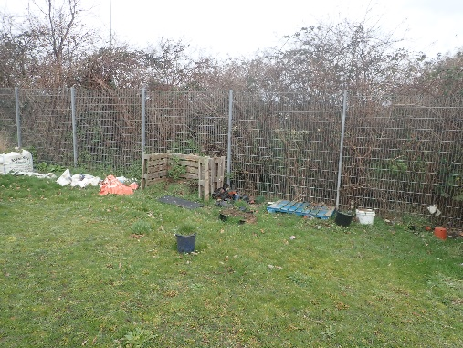
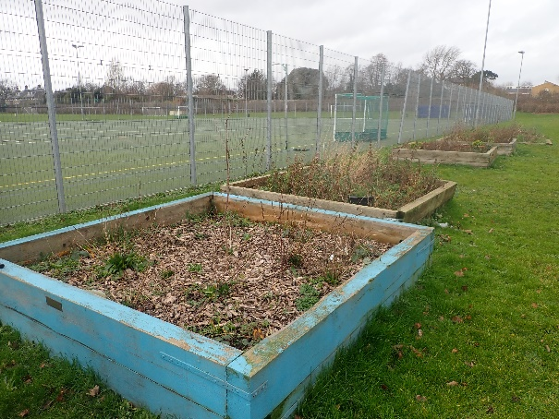

Upon taking over the community garden project, the aims and objectives were redefined. The aims of the garden were to:
- Provide a hub for local wildlife, particularly insects, amphibians and birds.
- Provide a space in which children can tangibly engage and learn about the natural world.
- To engender a culture of sustainability in the school culture and ethos.

The community garden aims to be a cross-curricular resource: a model for the sciences and geography, a supplier for technology and a source of inspiration for the arts. Achieving these aims is a multiyear project. However, I am pleased with the progress made this year.
Our first task was the somewhat symbolic one of planting saplings. The saplings chosen were choice favourites among pollinators, mammals and birds. These were crab apples, rowans, pussy willows and hazel. Tree guards were also built to avoid either deliberate or accidental damage. These saplings will take many, many years to develop and will be coppiced to not deprive the orchard of light (more on that shortly!). Unfortunately, the pussy willow saplings died. A soaking wet winter, rainless spring and scorching summer may have had something to do with that. At this point, the garden was still quite a miserable sight indeed.

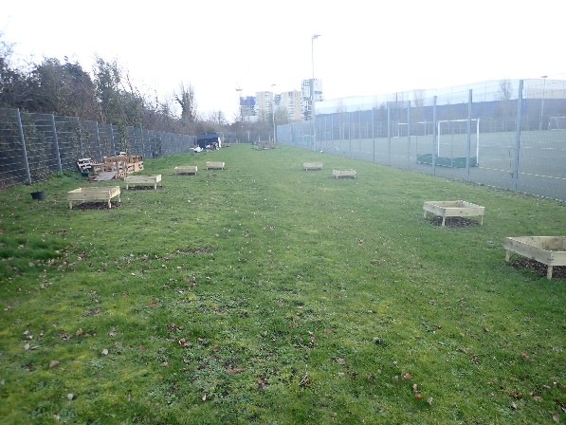

The next task was to repair and rejuvenate the raised beds. Many of these were half rotten and falling apart, so the mundane but necessary task of reassembling them was first priority. Years of neglect had also allowed the soil levels to drop and erode. With the help of a number of students in years 7 and 8, we cleared the vegetation in these beds, added a bit more drainage and filled them with new topsoil. The topsoil we went for was a more expensive blend, but one which paid and will continue to pay dividends in the quality of yields.
It was at this point that the world spiralled out of control and time seized exist. With the lockdown in place, I was able to reach a number of major milestones which would have otherwise taken a very long time to reach. Chief among these were: creating woodchip paths) around the beds for structure and future interplanting, creating several micro-habitats to attract native insects, amending soil previously damaged by leaking sandbags (why there were there to begin with I am still not sure) for future planting, building various planters and compost/leaf mould bins (five and counting!) and other less-than-eventful, routine tasks such as guttering and tending produce (tomatoes, cucumbers, onions, carrots, potatoes, runner beans, cabbage, cauliflower, courgettes and broccoli being this year’s harvest. Unfortunately, no one was around to buy these).
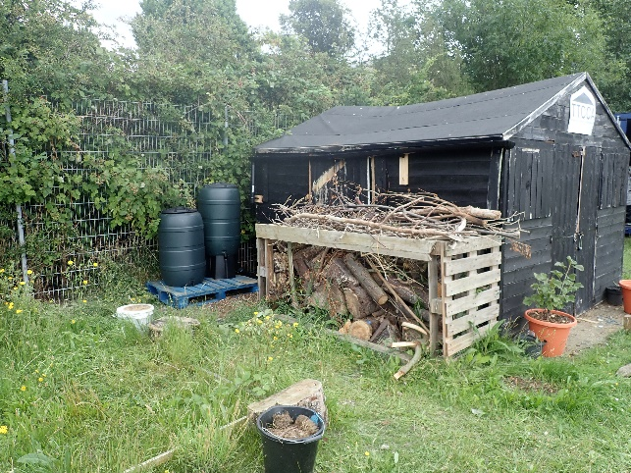
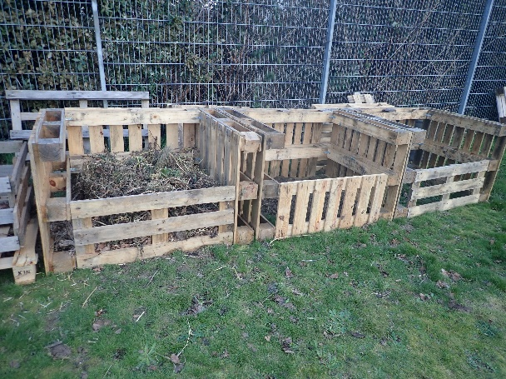
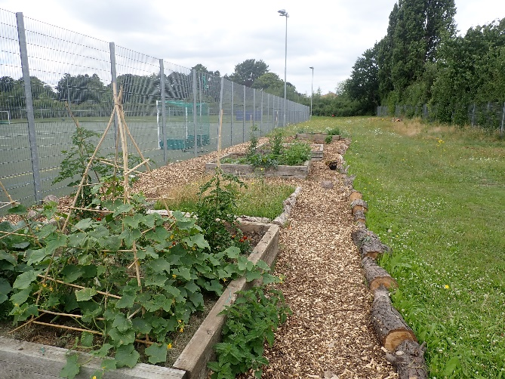
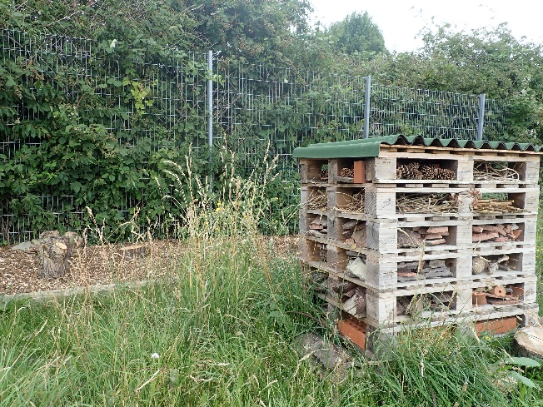

The real task of conservation gardening is not to bring in as many ‘pollinator friendly’ or similarly ‘good for bugs’ branded products but to work with what is already on site. Our job is not to shape or mould the natural world as to how we see fit but to gently steer what is already native to the garden to reach its full potential. A key example of this is the wildflower meadow. Creating a meadow from scratch is a laborious and often unworthwhile investment as its main benefactors are pollinators, which are hardly the most fussy of groups to begin with. Far more practical and useful from a wildlife perspective is to let the grass grow and see what is already there (and there is always more than expected!). This was exactly the laissez-faire approach taken in the community garden and it paid dividends. Dandelions, yarrow, wild carrot, teasles, clover, bird’s foot and oxe-eye daisies were all ready in the waiting for their time in the sun. Cutting this back in September, raking the grass to deprive the soil of nutrients and a dash of yellow rattle will only ensure the same next year and provide even more space for flowers amongst the grass and other species.
The progress made has been reflected in an increase in biodiversity noted in the garden. Below is a table outlining some of the species of birds and insect I have noted. Of especial note are lesser stag beetles (a still declining species of beetle), a kestrel and numerous butterflies. Also attached are a few choice photos of insets taken onsite.

Birds | Insects |  | Arachnids | Mammals
Kestrel | Butterflies | Brimstone | Woodlouse spider | Fox
Robin |  | Red admiral | Several orb weavers | Field mouse
Blackcap |  | Holly blue | Harvestmen
Parakeet |  | Small white | Wolf spider
Starling |  | Small heather
Blackbird |  | Comma
Magpie |  | Small copper
 |  | Jersey tiger moth
 |  | Peacock
 |  | Painted lady
 | Dragonflies | Male chaser
 |  | Southern hawker
 | Beetles | Lesser stag
 |  | Chafer beetle
 |  | Churchyard beetle
 |  | Ground beetle
 |  | Several ladybird species
 | Bees | Honey
 |  | Red tail bumblebee
 |  | Ash mining bee
 |  | Small copper
 |  | Leaf cutter
 | Molluscs | Leopard slugs
 |  | Garden slugs
 |  | Garden snail
 | Wasps | Ruby tailed
 |  | Cuckoo

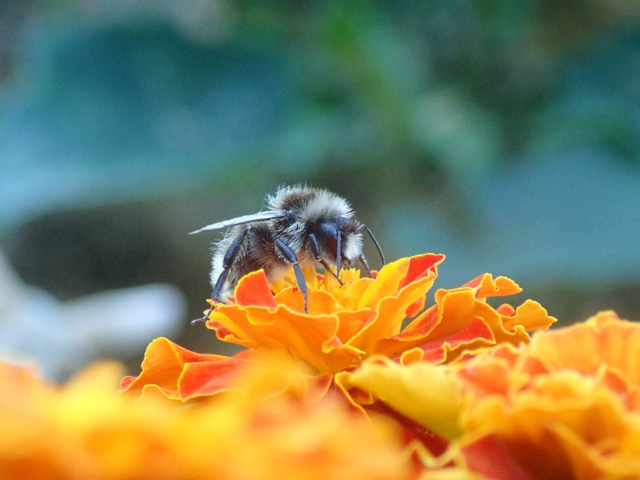
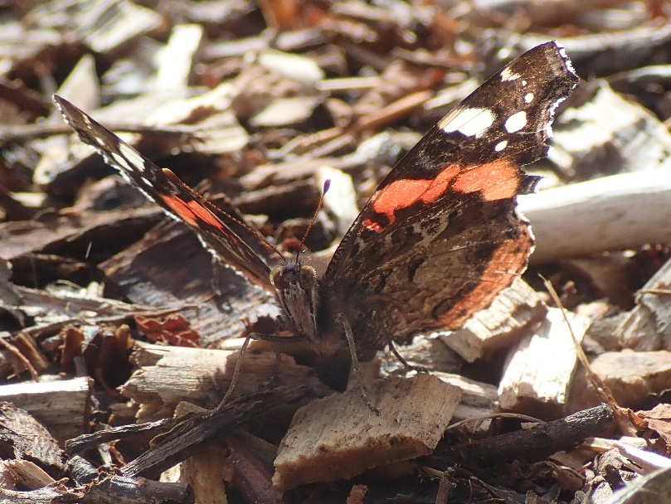

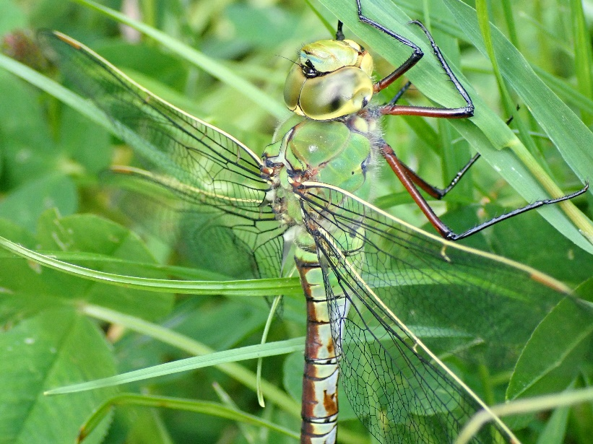

Over the next year, there are three main ambitions for the garden. These are:
- To build a pond
- To plant a small apple orchard.
- To build an apiary of two honey bee hives

The first task for the Autumn is to build a pond and bog area, roughly ten feet by ten feet. A pond is a must for any wildlife garden. Water attracts a number of insects and amphibians: water boatmen, pond snails, dragonfly nymphs, horse leeches, newts, toads, frogs, visiting birds, mammals (hopefully hedgehogs!) among many more. I was lucky enough to get 26 granite boulders for free, leaving only the pond liner, beech pebbles and various aquatic and marginal plants for purchase. Ponds are an amazing educational resource, allowing children who may otherwise have very limited contact with the natural world access to a teeming habitat.
As we approach the winter and trees enter their dormancy, the next task will be to plant an apple orchard. The apple orchard will serve a number of functions: it will fill a large space in the garden that would otherwise go unused, provide habitat and food for over 200 species and, of course, give us apples! An apple orchard will provide some much needed nectar and pollen for our pollinators while the apples themselves will provide a valuable winter food source for birds, mammals and invertebrates. My current leaning is toward semi-dwarf MM106 trees which grow to about fifteen feet with Braeburn, ‘discovery’ and cox’s pippin dessert varieties being top of the list. With these trees and 5m spacing, we will have space for 8-9 trees.
Toward May-July, the focus will be on bees. A number of primary schools have introduced bee keeping into their curriculum with great success. Charlton Manor particularly has made a fantastic job. Bees are the unsung heroines of our lives, directly pollinating 1/3 of the food we eat! Keeping bees onsite requires a number of measures being in place: a cage to prevent access by stray children, suits and smokers for honey extraction and training for volunteer staff. However, there is bad news. Against popular belief, recent research shows that there are in fact too many hives in London! To be clear: bees are not the issue. The issue is that whilst there is a growing interest in bee keeping (especially ‘roof top hives’), there does not appear to be a similar interest in planting the flowers on which bees live. In other words, there are not enough flowers in London to sustain the number of hives, leading to lowered honey production and greater hive loss. It is for these reasons that flowers (chief among which will be our apples) must take centre stage.
All of the above has been leading to my final point: a plea for bees. Following meetings with local bee keepers, I estimate that an apiary of this size and purpose can be up to £1500. Although it pains me to say, honeybees are only one species. As important as they are, they are one among many pollinating species including flies, hoverflies, moths, butterflies, mammals and other species of bee. The flowers, pond and orchards will support these often neglected species. It is my intention to use the £1000 gathered by the PTFA on the orchard, pond and various flower patches. Funding for the apiary must be raised via crowd funding and local donors.

